# Kernel 代码漏洞

项目名称：Kernel

扫描时间：2022年12月14日

漏洞总览

|  |  |  |
| --- | --- | --- |
| 序号 | 漏洞 | 文件路径 |
| 1 | CVE-2021-41864 | kernel/kernel/bpf/stackmap.c |
| 2 | CVE-2017-16996 | kernel/kernel/bpf/verifier.c |
| 3 | CVE-2012-2745 | kernel/kernel/cred.c |
| 4 | CVE-2021-35039 | kernel/kernel/module.c |
| 5 | CVE-2022-30594 | kernel/kernel/ptrace.c |
| 6 | CVE-2018-20784 | kernel/kernel/sched/fair.c |
| 7 | CVE-2013-3301 | kernel/kernel/trace/ftrace.c |

（*注：可通过带点击漏洞名称跳转到详情。获取更好体验请访问：[home.blueoriginguardian.com](http://home.blueoriginguardian.com)。）

## [CVE-2021-41864](https://nvd.nist.gov/vuln/detail/CVE-2021-41864)

1. 文件路径：kernel/kernel/bpf/stackmap.c
2. 存储库：[torvalds/linux](https://github.com/torvalds/linux)
3. 存储库提交标识（commit ID）：[30e29a9a2bc6a4888335a6ede968b75cd329657a](https://github.com/torvalds/linux/commit/30e29a9a2bc6a4888335a6ede968b75cd329657a?diff=split#diff-0486cadd28c1d1b35dd24db437ba3ce1b85b67ec8f0fb4901b28704098ad1d1b)
4. 匹配文件：kernel/bpf/stackmap.c
5. 修复文件：kernel/bpf/stackmap.c
6. 匹配代码和修复建议如下：

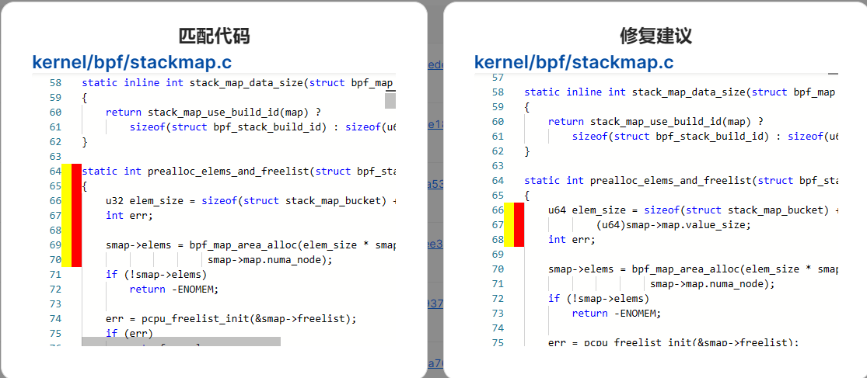



## [CVE-2017-16996](https://nvd.nist.gov/vuln/detail/CVE-2017-16996)

1. 文件路径：kernel/kernel/bpf/verifier.c
2. 存储库：[torvalds/linux](https://github.com/torvalds/linux)
3. 存储库提交标识（commit ID）：[0c17d1d2c61936401f4702e1846e2c19b200f958](https://github.com/torvalds/linux/commit/0c17d1d2c61936401f4702e1846e2c19b200f958?diff=split#diff-edbb57adf10d1ce1fbb830a34fa92712fd01db1fbd9b6f2504001eb7bcc7b9d0)
4. 匹配文件：kernel/bpf/verifier.c
5. 修复文件：kernel/bpf/verifier.c
6. 匹配代码和修复建议如下：（暂无）

## [CVE-2012-2745](https://nvd.nist.gov/vuln/detail/CVE-2012-2745)

1. 文件路径：kernel/kernel/cred.c
2. 存储库：[torvalds/linux](https://github.com/torvalds/linux)
3. 存储库提交标识（commit ID）：[79549c6dfda0603dba9a70a53467ce62d9335c33](https://github.com/torvalds/linux/commit/79549c6dfda0603dba9a70a53467ce62d9335c33?diff=split#diff-3cb5667a88a24e8d5abc7042f5c4193698d6b962157f637f9729e61198eec63a)
4. 匹配文件：kernel/cred.c
5. 修复文件：kernel/cred.c
6. 匹配代码和修复建议如下：

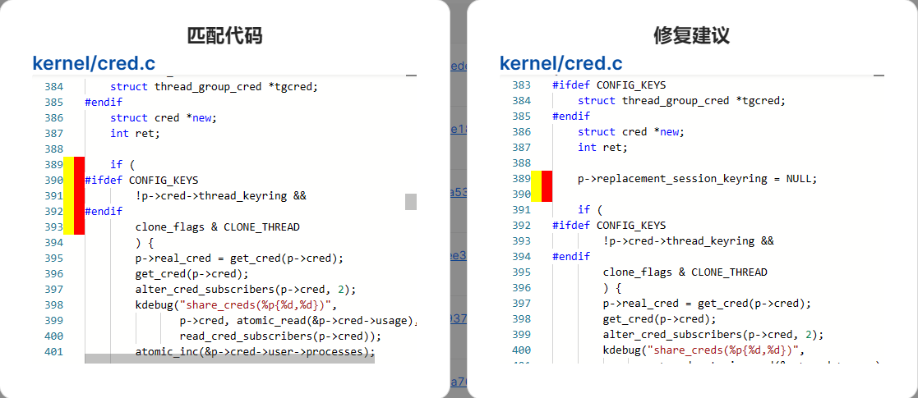



## [CVE-2021-35039](https://nvd.nist.gov/vuln/detail/CVE-2021-35039)

1. 文件路径：kernel/kernel/module.c
2. 存储库：[torvalds/linux](https://github.com/torvalds/linux)
3. 存储库提交标识（commit ID）：[0c18f29aae7ce3dadd26d8ee3505d07cc982df75](https://github.com/torvalds/linux/commit/0c18f29aae7ce3dadd26d8ee3505d07cc982df75?diff=split#diff-14b05e05adbe24dec671f25cfc3e6d0393c889cfc84ced54d1a82acb06881b40)
4. 匹配文件：kernel/module.c
5. 修复文件：kernel/module.c
6. 匹配代码和修复建议如下：

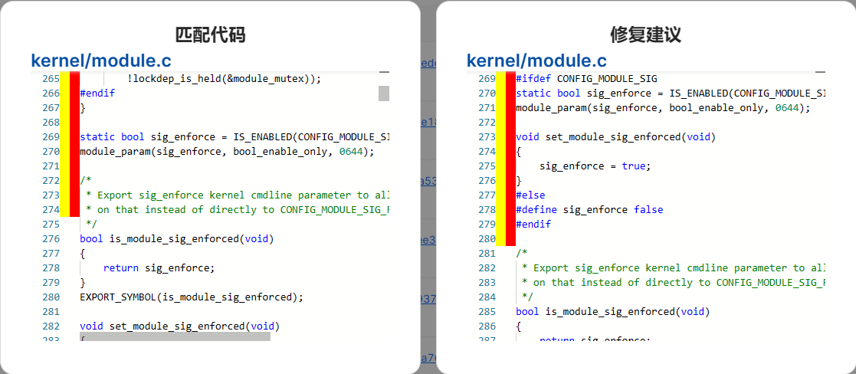



## [CVE-2022-30594](https://nvd.nist.gov/vuln/detail/CVE-2022-30594)

1. 文件路径：kernel/kernel/ptrace.c
2. 存储库：[torvalds/linux](https://github.com/torvalds/linux)
3. 存储库提交标识（commit ID）：[ee1fee900537b5d9560e9f937402de5ddc8412f3](/ee1fee900537b5d9560e9f937402de5ddc8412f3?diff=split#diff-421f5a7dbe3c3ab70394a063d8703ba2f4f3ebecd295847c1672928b866152e6)
4. 匹配文件：kernel/ptrace.c
5. 修复文件：kernel/ptrace.c
6. 匹配代码和修复建议如下：

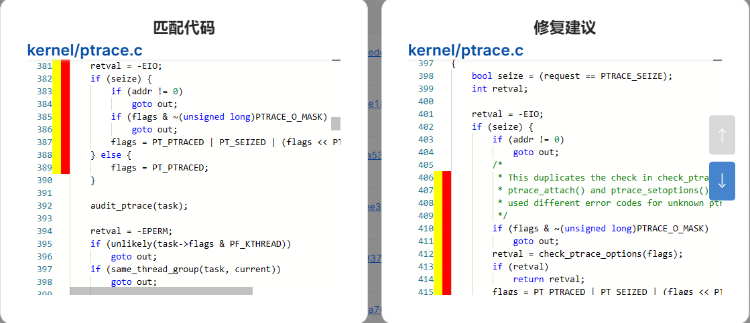



## [CVE-2018-20784](https://nvd.nist.gov/vuln/detail/CVE-2018-20784)

1. 文件路径：kernel/kernel/sched/fair.c
2. 存储库：[torvalds/linux](https://github.com/torvalds/linux)
3. 存储库提交标识（commit ID）：[c40f7d74c741a907cfaeb73a7697081881c497d0](https://github.com/torvalds/linux/commit/c40f7d74c741a907cfaeb73a7697081881c497d0?diff=split#diff-75a417d0e6ebb27175a48c6810294ab6e21847776b1e46c62de9cccfb428883e)
4. 匹配文件：kernel/sched/fair.c
5. 修复文件：kernel/sched/fair.c
6. 匹配代码和修复建议如下：

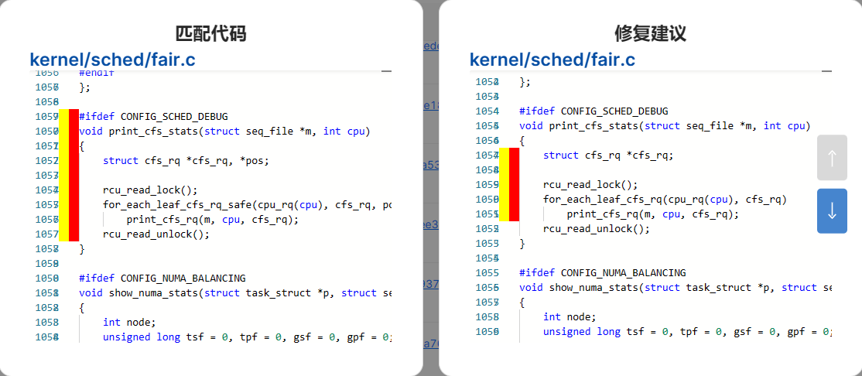

## [CVE-2013-3301](https://nvd.nist.gov/vuln/detail/CVE-2013-3301)

1. 文件路径：kernel/kernel/trace/ftrace.c
2. 存储库：[torvalds/linux](https://github.com/torvalds/linux)
3. 存储库提交标识（commit ID）：[6a76f8c0ab19f215af2a3442870eeb5f0e81998d](https://github.com/torvalds/linux/commit/6a76f8c0ab19f215af2a3442870eeb5f0e81998d?diff=split#diff-bf58468d9729615e41d445f15baf8297f56de7793b006b9e373ff21adf20d000)
4. 匹配文件：kernel/trace/ftrace.c
5. 修复文件：kernel/trace/ftrace.c
6. 匹配代码和修复建议如下：

